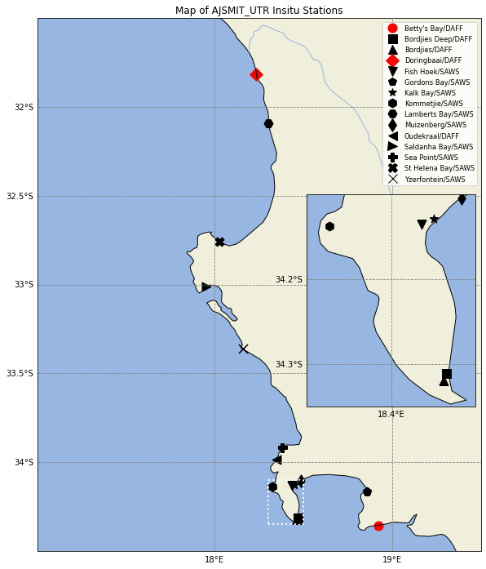

Figure 1Figure 1: Stations map detailing the station locations (left) and the CROCO mean sea state with in situ sampling stations (right)

|  |  |  |
| --- | --- | --- |
|  |  |  |

Figure 2: Figure 2: SWCC CROCO model domain with validation in situ data locations overlaid with mean sea state over the 2009-2013 validation period.

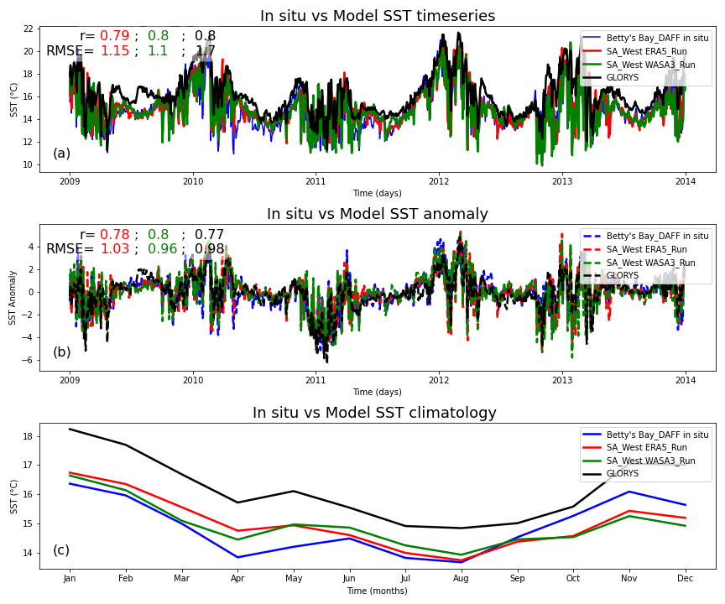

Figure 3: SST validation of the SA West Model, ERA5 and WASA3 wind forced configurations at Betty's Bay DAFF station located at [-34.359]: [18.922], depth = 5 m and a comparison with GLORYS global model. Subplot (a) shows SST time series, (b) shows anomaly series and (c) shows the climatology of the in situ SST vs the model outputs.

Table 1: Betty’s Bay total and seasonal statistics at 5 m where CROCO model depth is 13 m.

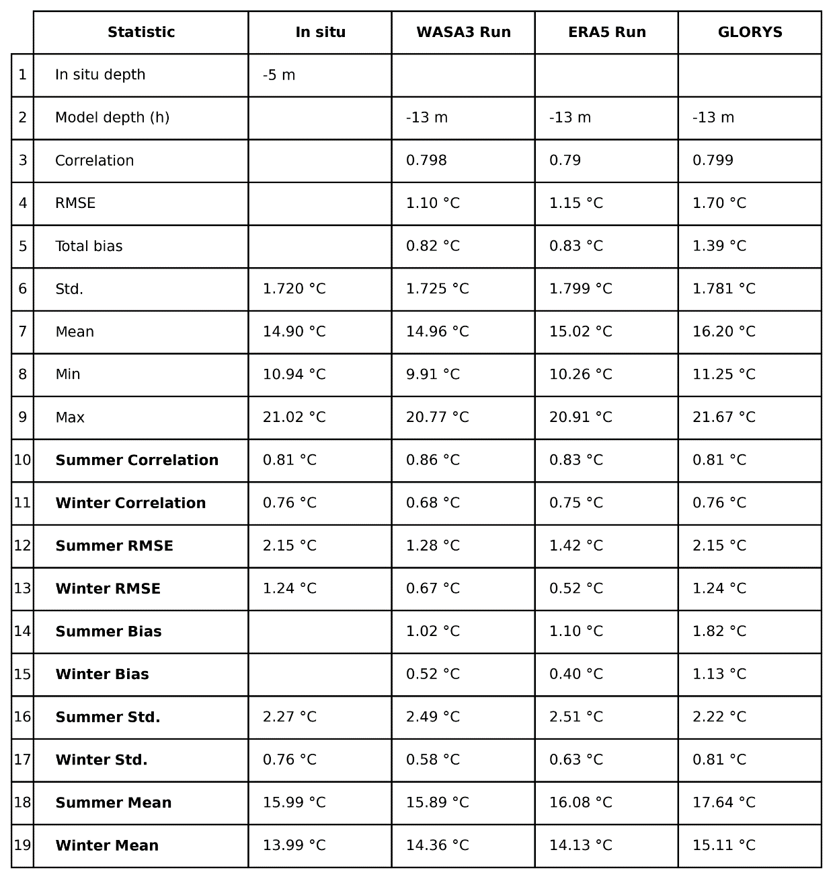

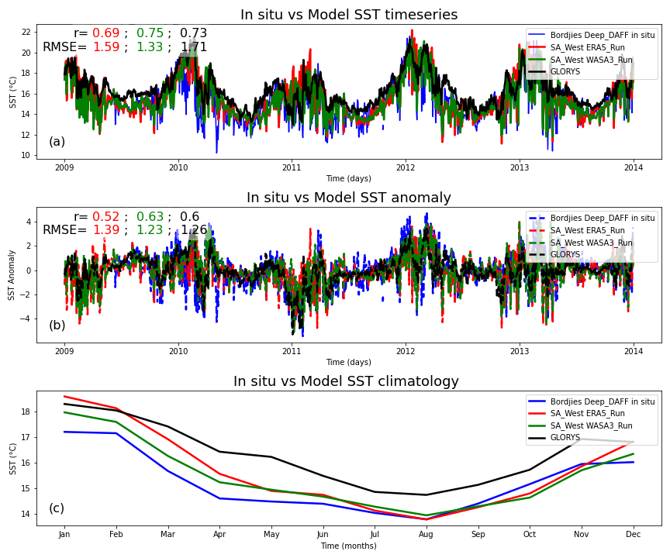

Figure 4: SST validation of the SA West Model, both the ERA5 and WASA3 wind forced configurations at Bordjies Deep DAFF station located at [-34.31]: [18.465], depth = 9 m and a comparison with GLORYS global model. Subplot (a) shows SST time series, (b) shows anomaly series and (c) shows the climatology of the in situ SST vs the model outputs.

Table 2: Bordjies Deep DAFF UTR total and seasonal statistics at 9 m where CROCO model depth is 17 m.

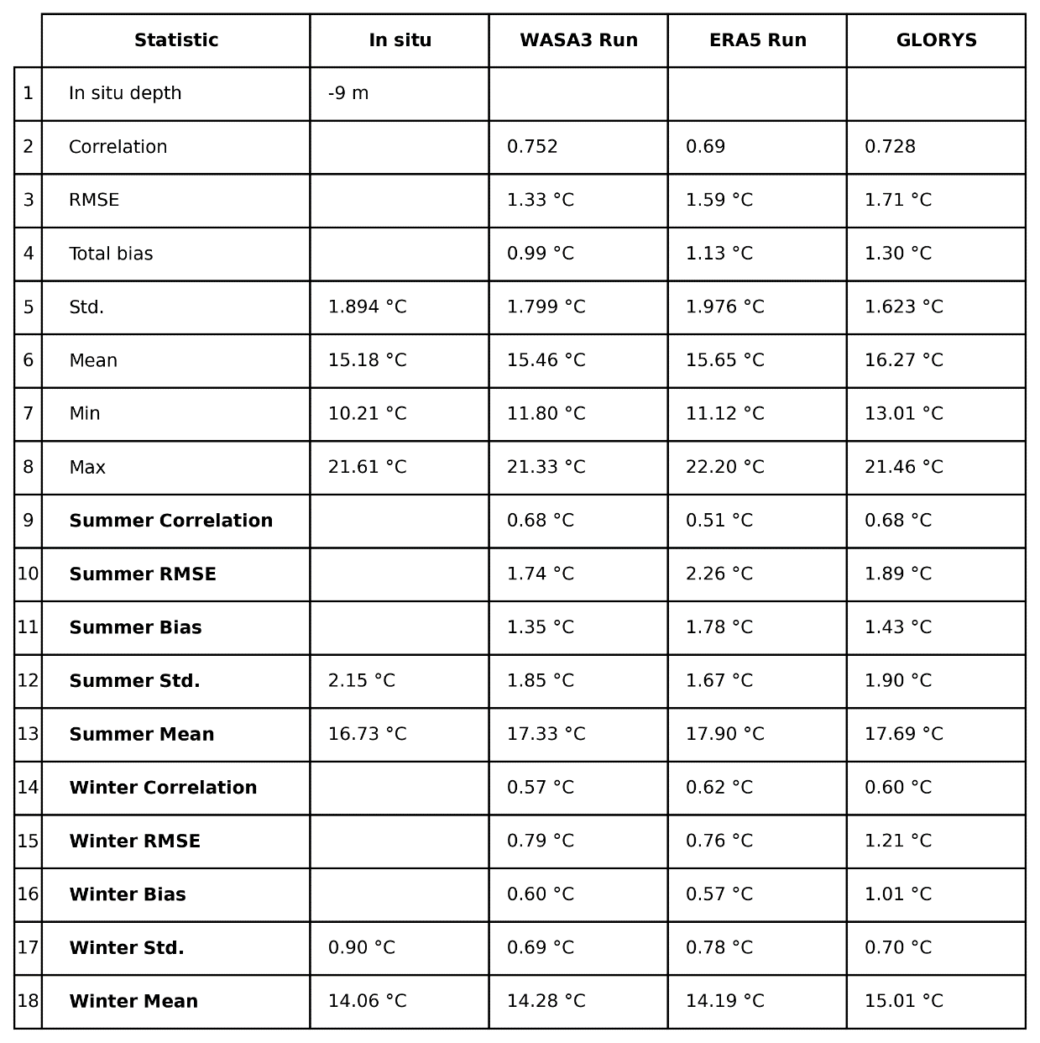

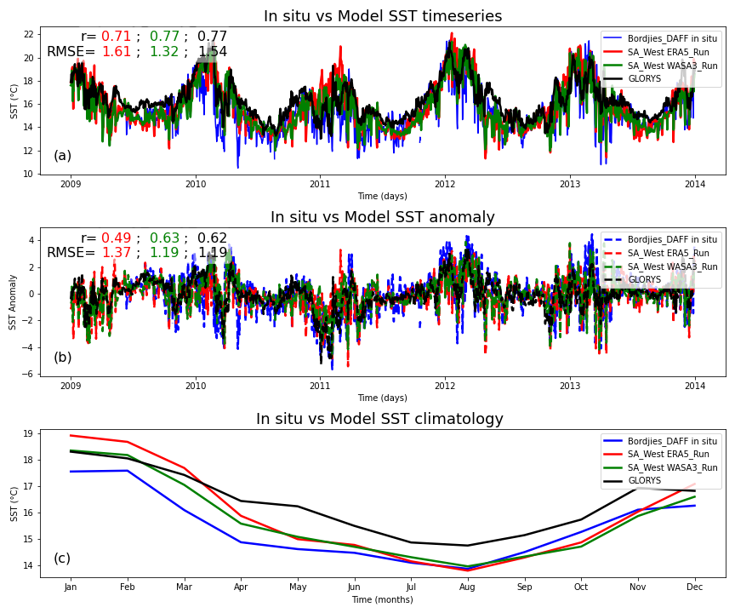

Figure 5: SST validation of the SA_West Model, both the ERA5 and WASA3 wind forced configurations at Bordjies DAFF station located at [-34.32]: [18.462], depth = 4 m and a comparison with GLORYS global model. Subplot (a) shows SST time series, (b) shows anomaly series and (c) shows the climatology of the in situ SST vs the model outputs.

Table 3: Bordjies DAFF UTR total and seasonal statistics at 4 m where CROCO model depth is 17 m.

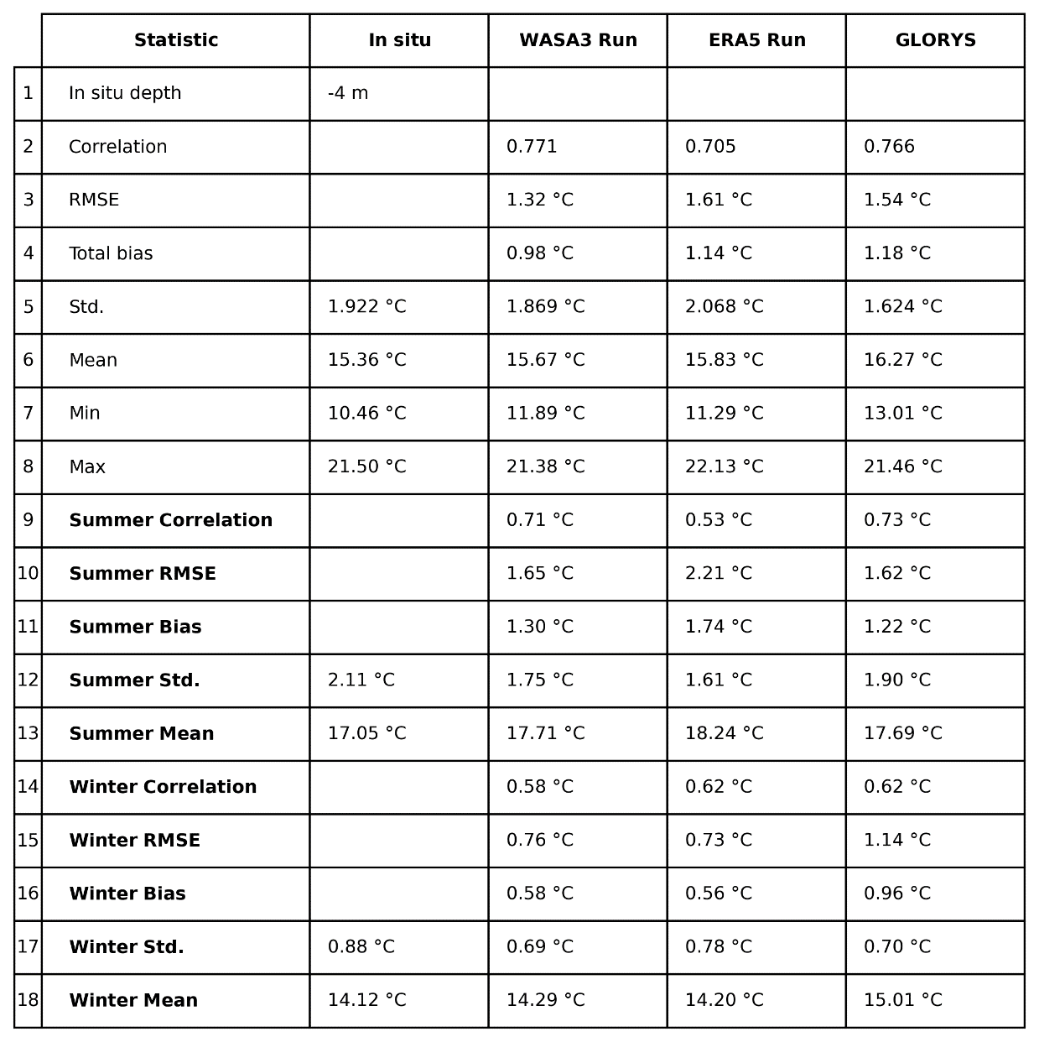

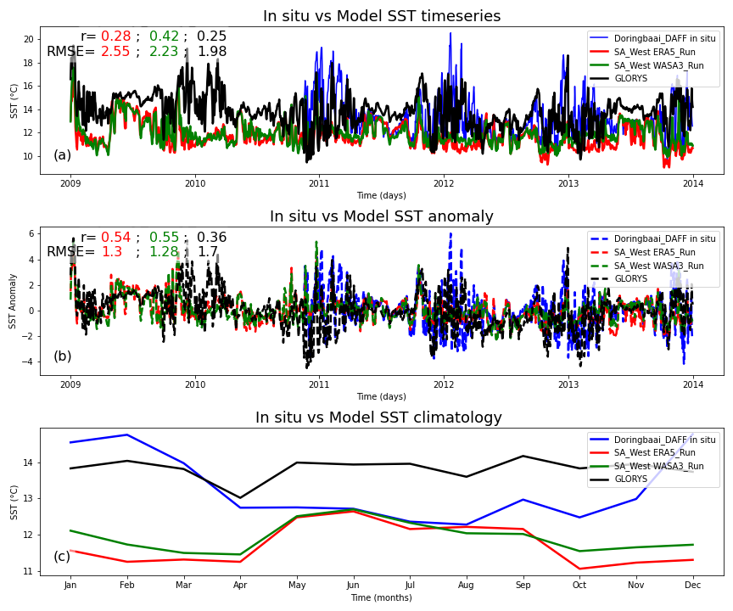

Figure 6: SST validation of the SA_West Model, both the ERA5 and WASA3 wind forced configurations at Doringbaai DAFF station located at [-31.817]: [18.231], depth = 0 m and a comparison with GLORYS global model. Subplot (a) shows SST time series, (b) shows anomaly series and (c) shows the climatology of the in situ SST vs the model outputs.

Table 4: Dorringbaai DAFF UTR total and seasonal statistics at surface where CROCO model depth is 27 m.

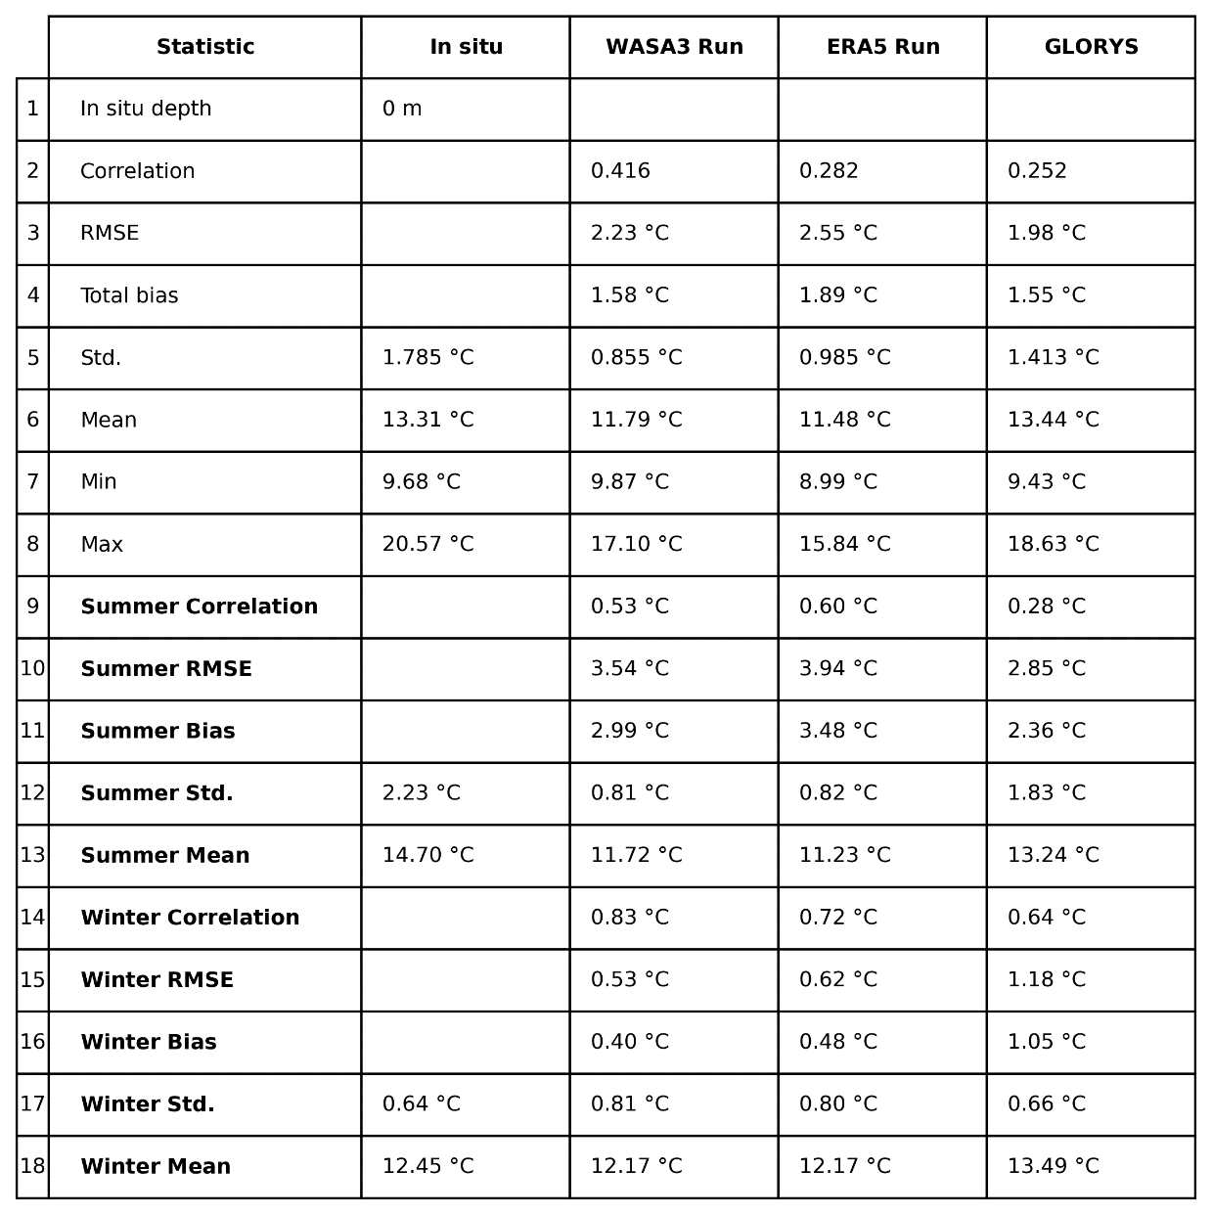

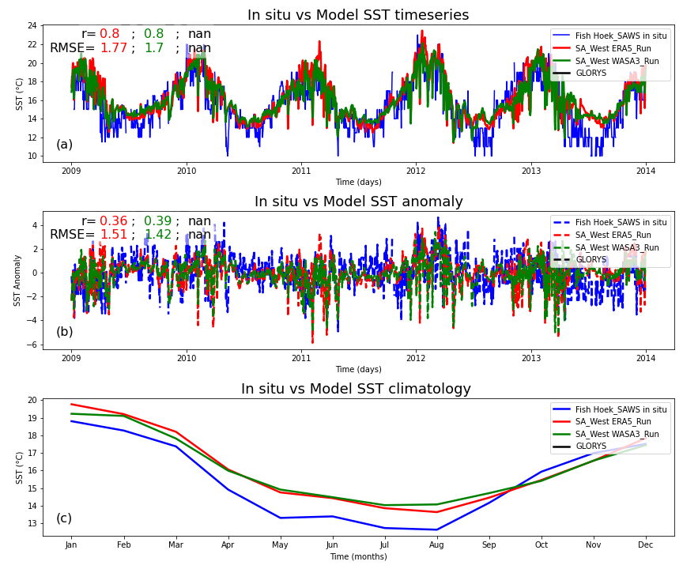

Figure 7: SST validation of the SA_West Model, both the ERA5 and WASA3 wind forced configurations at Fish Hoek SAWS station located at [-34.135]: [18.436], depth = 0 m and a comparison with GLORYS global model. Subplot (a) shows SST time series, (b) shows anomaly series and (c) shows the climatology of the in situ SST vs the model outputs.

Table 5: Fish Hoek SAWS total and seasonal statistics at surface where CROCO model depth is 13 m.

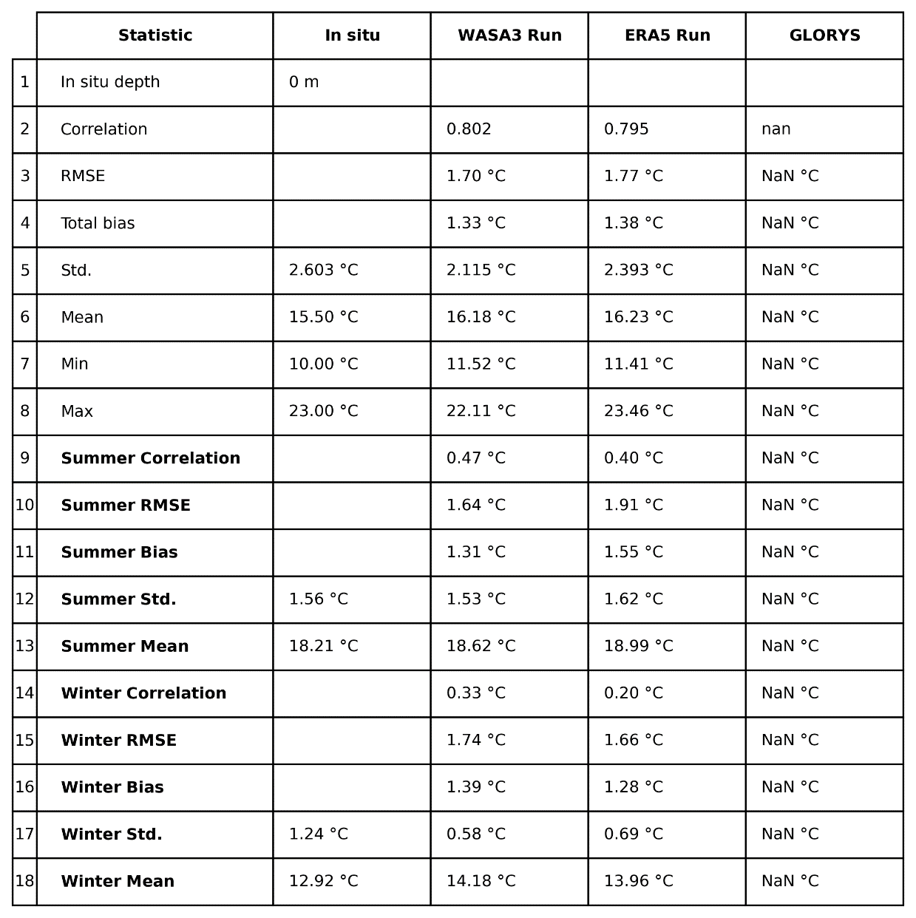

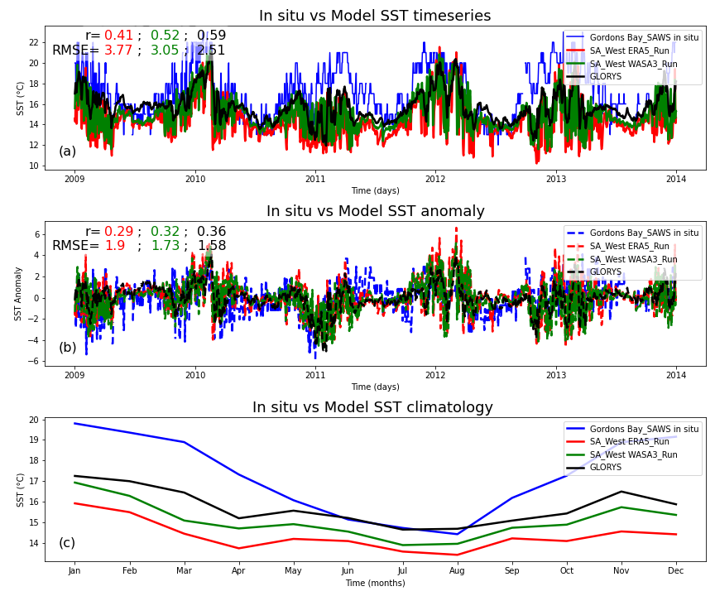

Figure 8: SST validation of the SA_West Model, both the ERA5 and WASA3 wind forced configurations at Gordons Bay SAWS station located at [-34.163]: [18.859], depth = 0 m and a comparison with GLORYS global model. Subplot (a) shows SST time series, (b) shows anomaly series and (c) shows the climatology of the in situ SST vs the model outputs.

Table 6: Gordons Bay_SAWS UTR total and seasonal statistics at surface where CROCO model depth is 17 m.



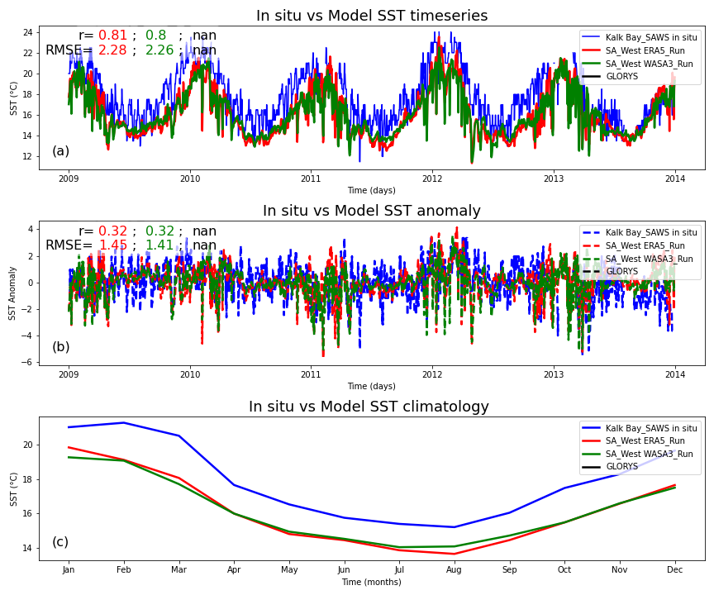

Figure 9: SST validation of the SA_West Model, both the ERA5 and WASA3 wind forced configurations at Kalk Bay SAWS station located at [-34.128]: [18.451], depth = 0 m and a comparison with GLORYS global model. Subplot (a) shows SST time series, (b) shows anomaly series and (c) shows the climatology of the in situ SST vs the model outputs.

Table 7: Kalk Bay SAWS UTR total and seasonal statistics at surface where CROCO model depth is 11 m.



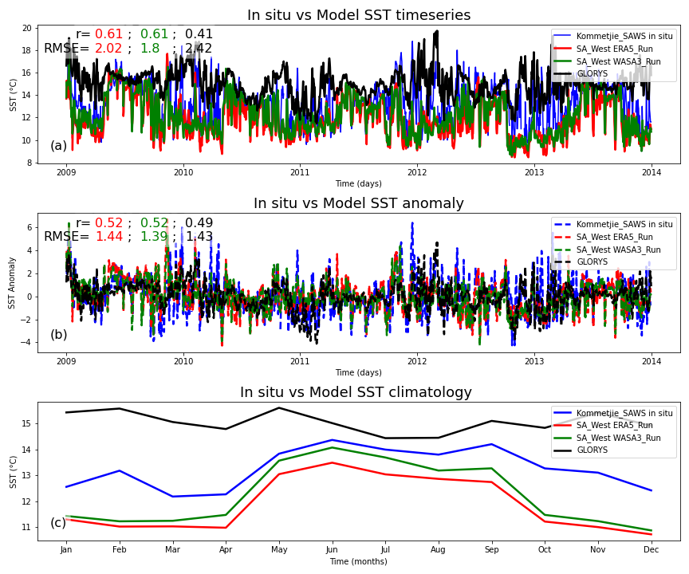

Figure 10: SST validation of the SA_West Model, both the ERA5 and WASA3 wind forced configurations at Kommetjie_SAWS station located at [-34.137]: [18.327], depth = 0 m and a comparison with GLORYS global model. Subplot (a) shows SST time series, (b) shows anomaly series and (c) shows the climatology of the in situ SST vs the model outputs.

Table 8: Kommetjie SAWS UTR total and seasonal statistics at surface where CROCO model depth is 31 m.

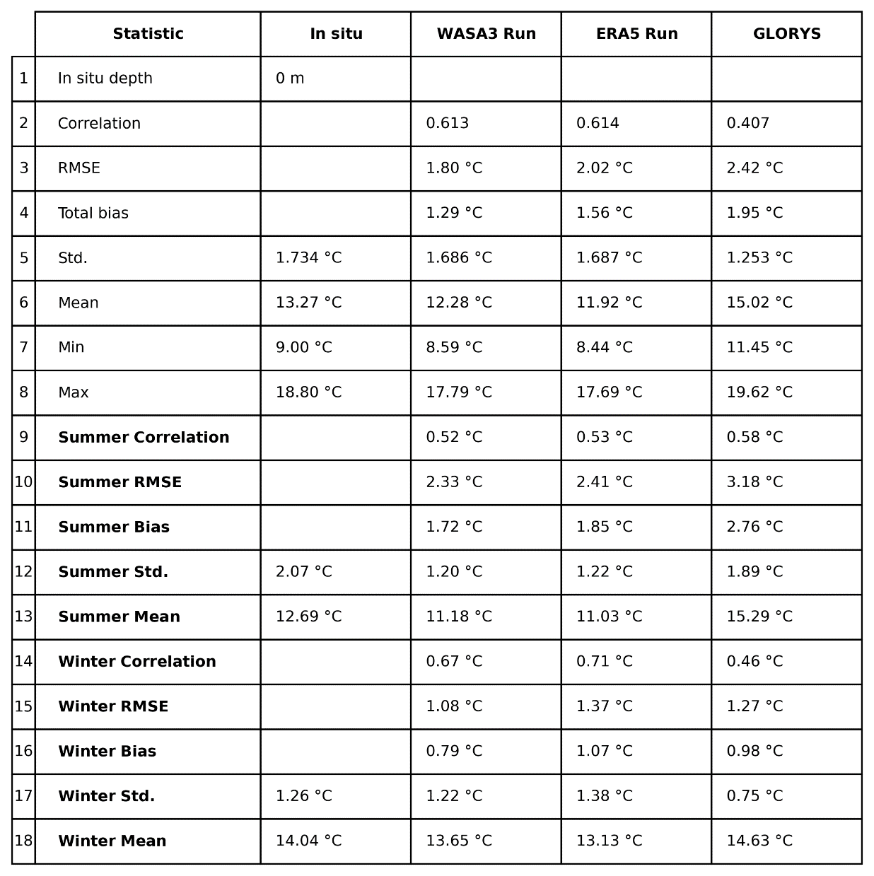

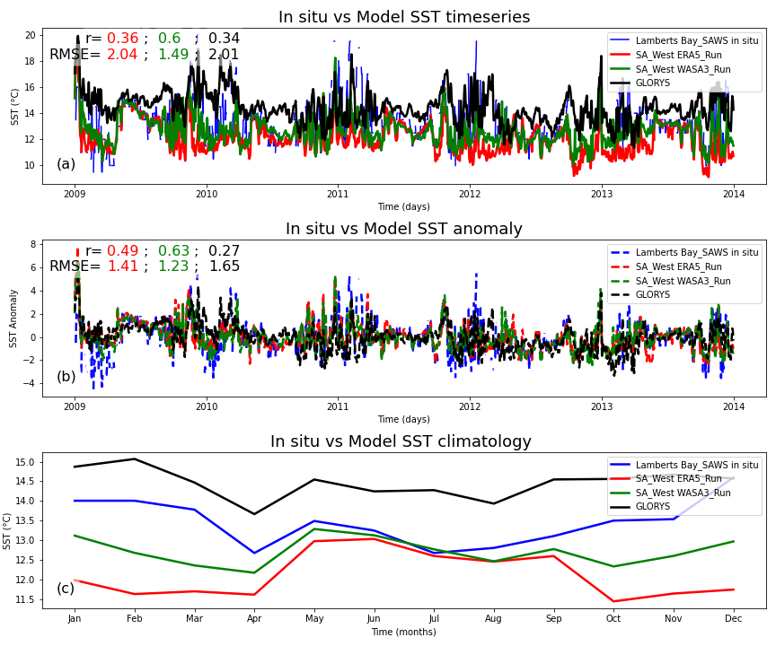

Figure 11: SST validation of the SA_West Model, both the ERA5 and WASA3 wind forced configurations at Lamberts Bay_SAWS station located at [-32.092]: [18.303], depth = 0 m and a comparison with GLORYS global model. Subplot (a) shows SST time series, (b) shows anomaly series and (c) shows the climatology of the in situ SST vs the model outputs.

Table 9: Lambarts Bay SAWS UTR total and seasonal statistics at surface where CROCO model depth is 15 m.

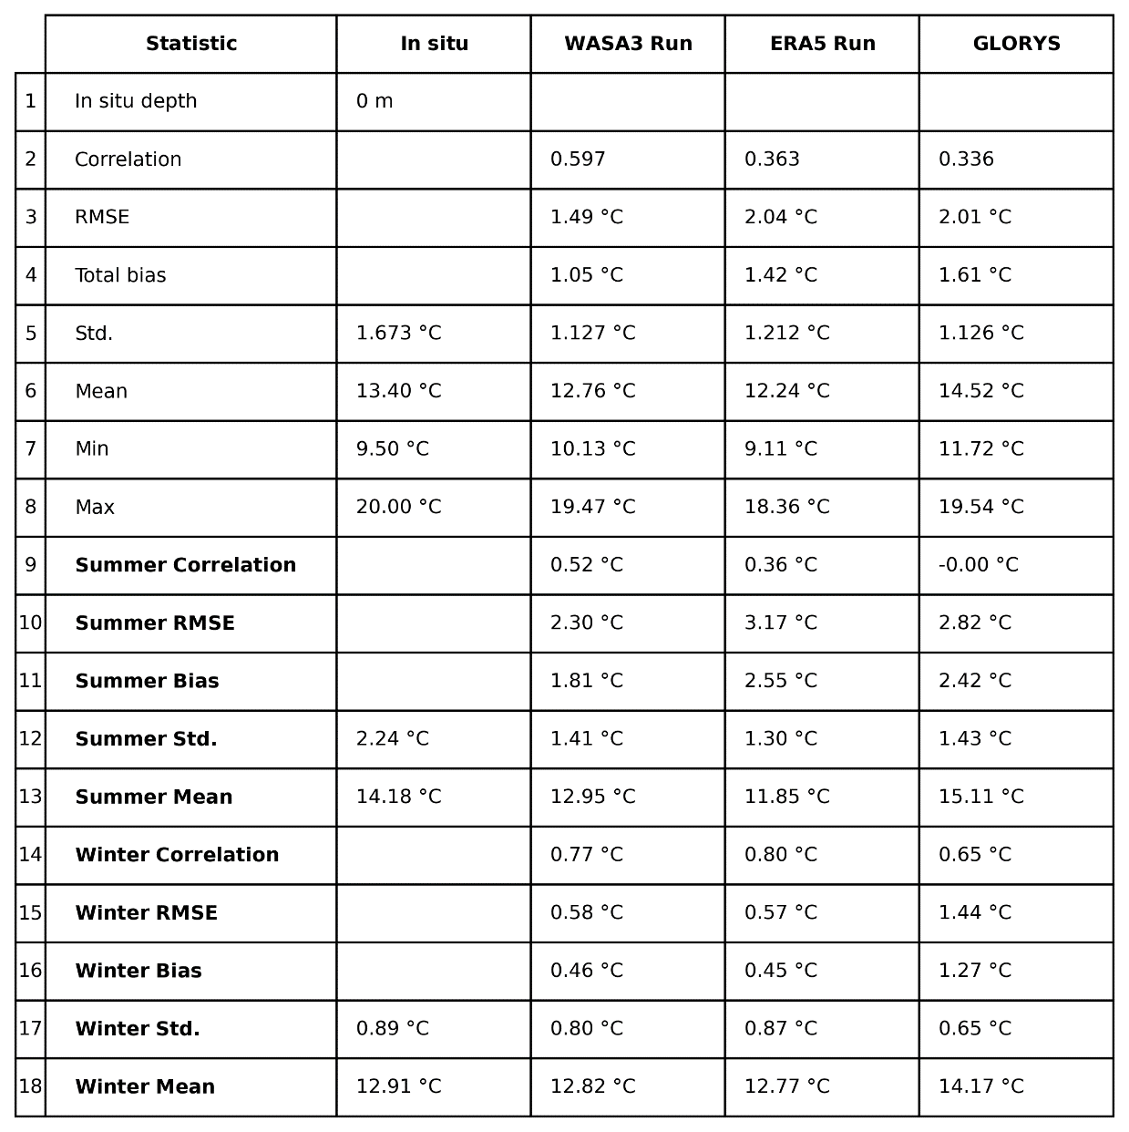

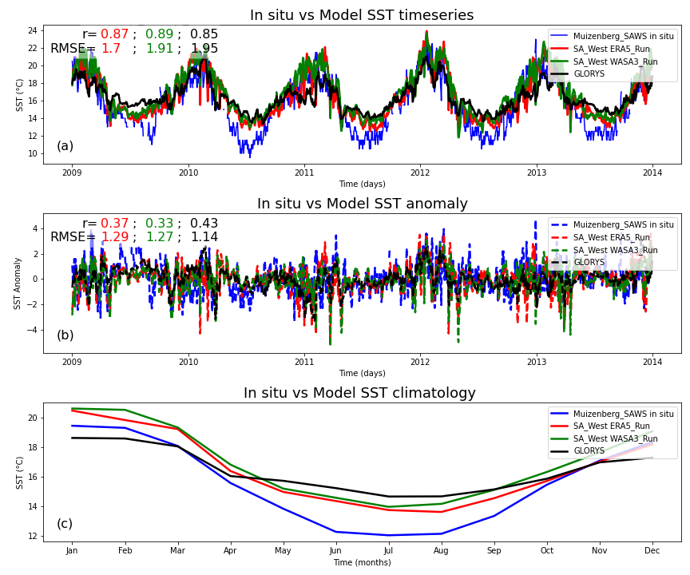

Figure 12: SST validation of the SA_West Model, both the ERA5 and WASA3 wind forced configurations at Muizenberg_SAWS station located at [-34.104]: [18.484], depth = 0 m and a comparison with GLORYS global model. Subplot (a) shows SST time series, (b) shows anomaly series and (c) shows the climatology of the in situ SST vs the model outputs.

Table 10: Muizenburg SAWS UTR total and seasonal statistics at surface where CROCO model depth is 7 m.

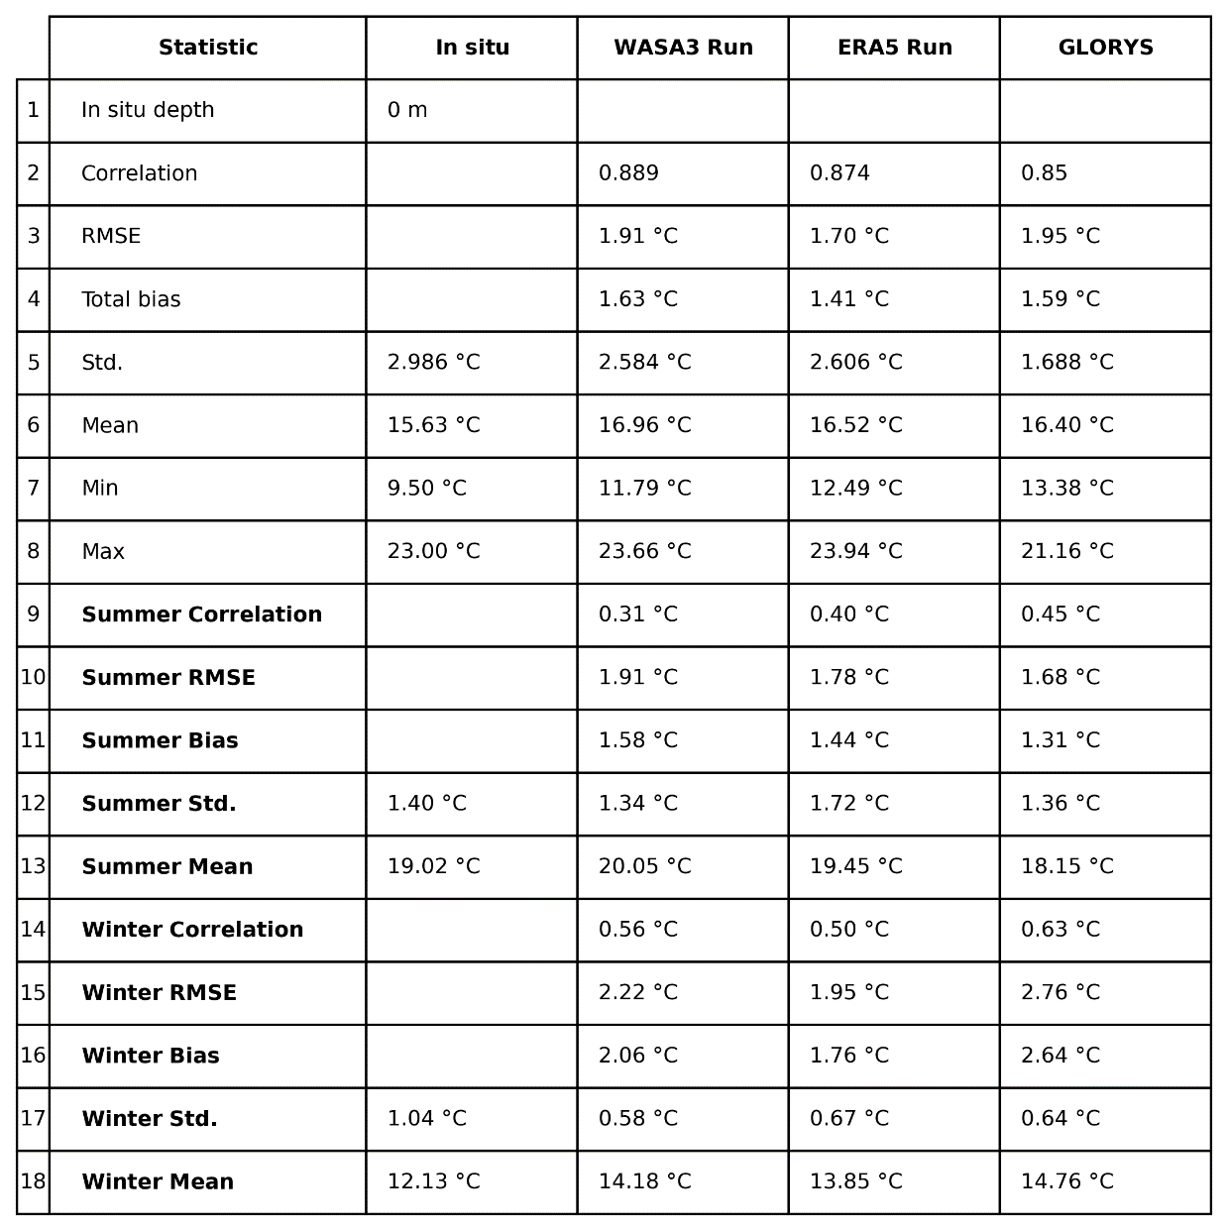

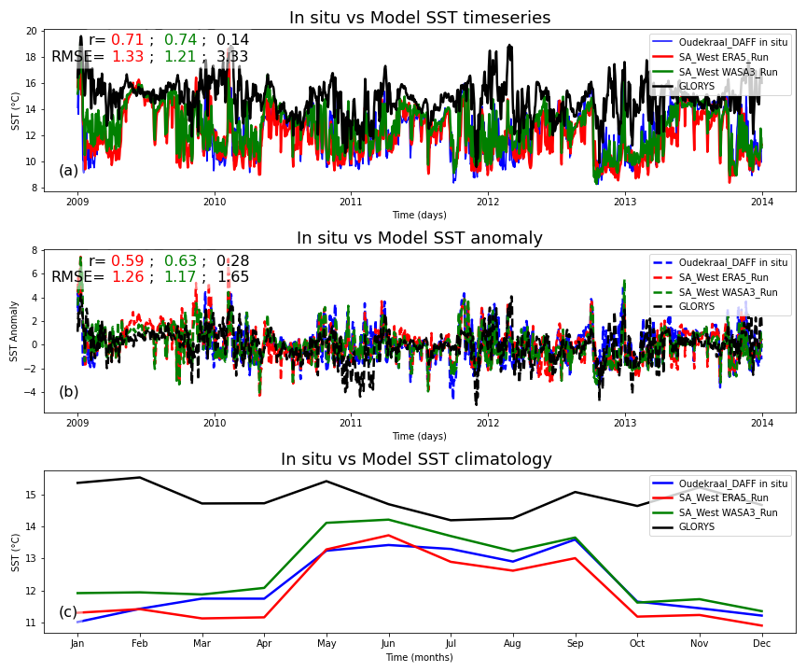

Figure 13: SST validation of the SA_West Model, both the ERA5 and WASA3 wind forced configurations at Oudekraal DAFF station located at [-33.985]: [18.346], depth = -9 m and a comparison with GLORYS global model. Subplot (a) shows SST time series, (b) shows anomaly series and (c) shows the climatology of the in situ SST vs the model outputs.

Table 11: Oudekraal SAWS UTR total and seasonal statistics at 9 m where CROCO model depth is 16 m.

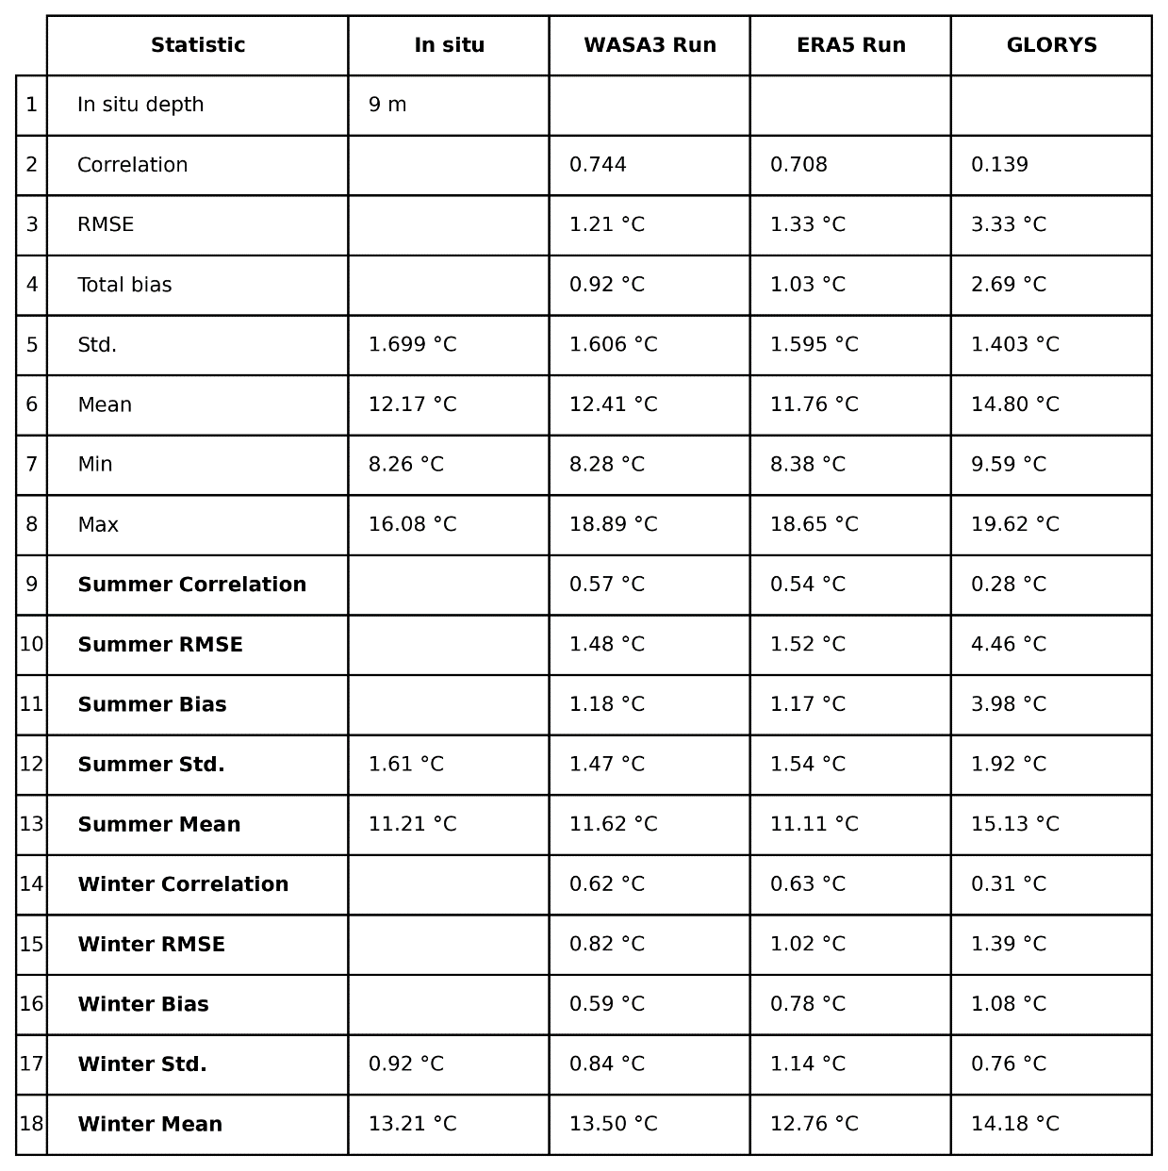

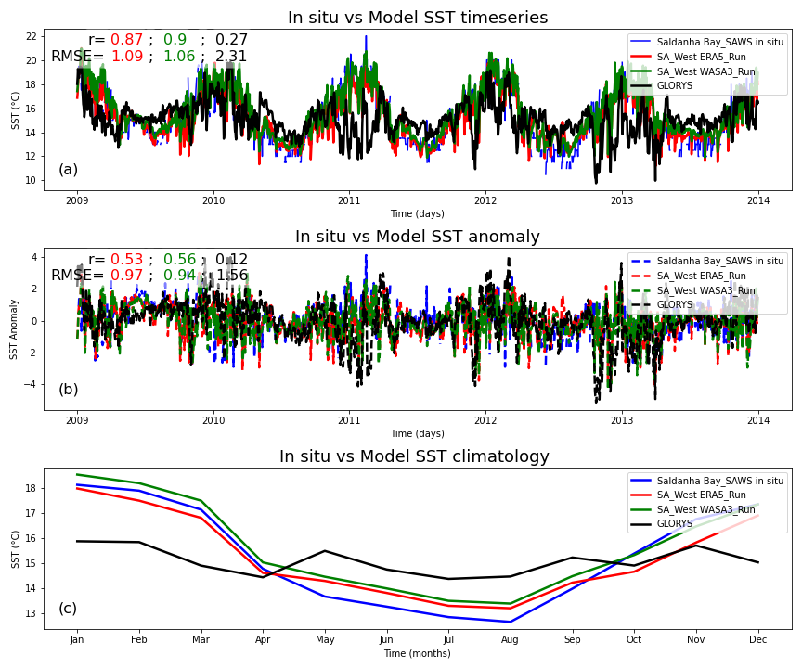

Figure 14: SST validation of the SA_West Model, both the ERA5 and WASA3 wind forced configurations at Saldanha Bay_SAWS station located at [-33.011]: [17.951], depth = 0 m and a comparison with GLORYS global model. Subplot (a) shows sst time series, (b) shows anomaly series and (c) shows the climatology of the in situ sst vs the model outputs.

Table 12: Saldanha Bay SAWS UTR total and seasonal statistics at surface where CROCO model depth is 13 m.

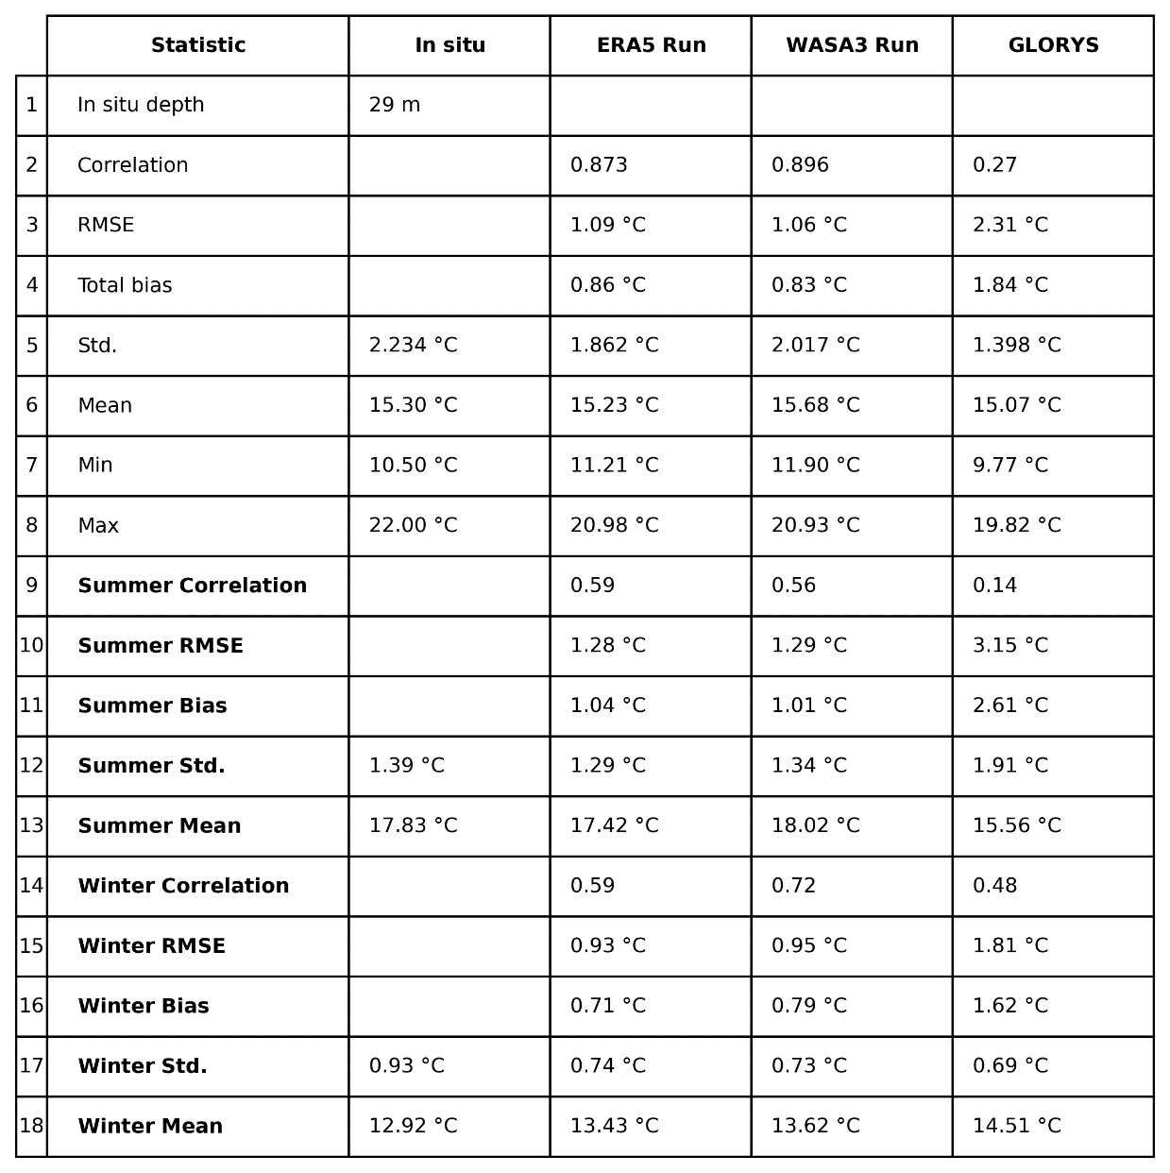

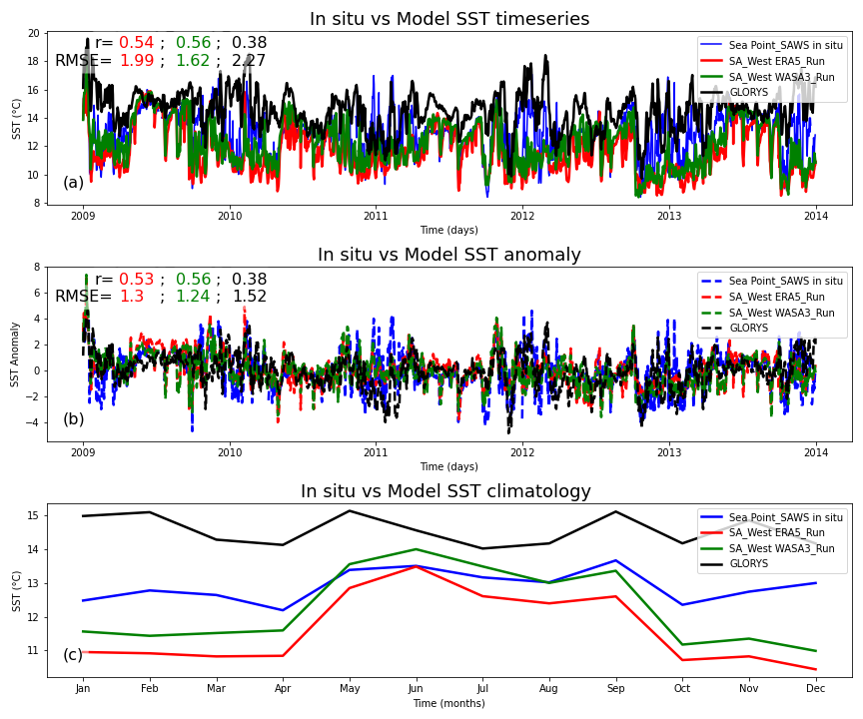

Figure 15: SST validation of the SA_West Model, both the ERA5 and WASA3 wind forced configurations at Sea Point_SAWS station located at [-33.918]: [18.382], depth = 0 m and a comparison with GLORYS global model. Subplot (a) shows sst time series, (b) shows anomaly series and (c) shows the climatology of the in situ sst vs the model outputs.

Table 13: Sea Point SAWS UTR total and seasonal statistics at surface where CROCO model depth is 25 m.

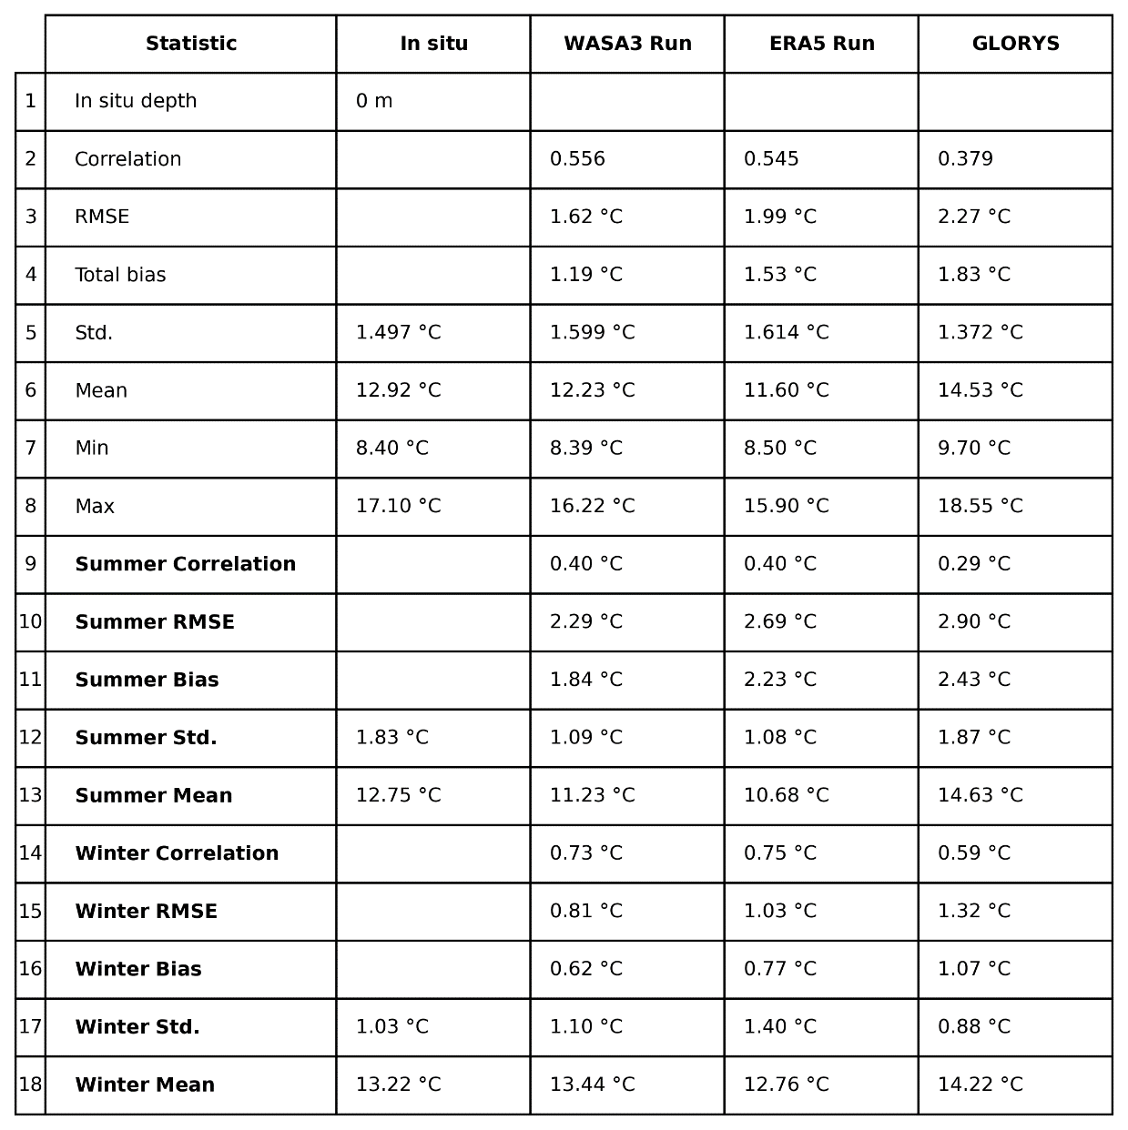

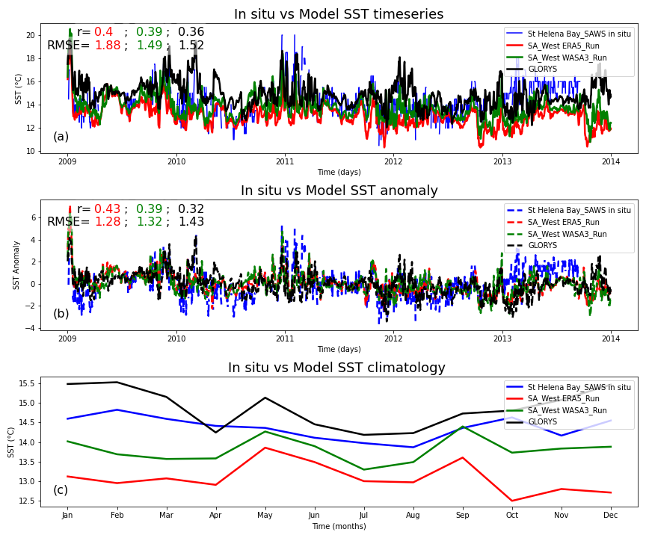

Figure 16: SST validation of the SA_West Model, both the ERA5 and WASA3 wind forced configurations at St Helena Bay_SAWS station located at [-32.758]: [18.028], depth = 0 m and a comparison with GLORYS global model. Subplot (a) shows SST time series, (b) shows anomaly series and (c) shows the climatology of the in situ SST vs the model outputs.

Table 14: St Helena Bay SAWS UTR total and seasonal statistics at surface where CROCO model depth is 11 m.

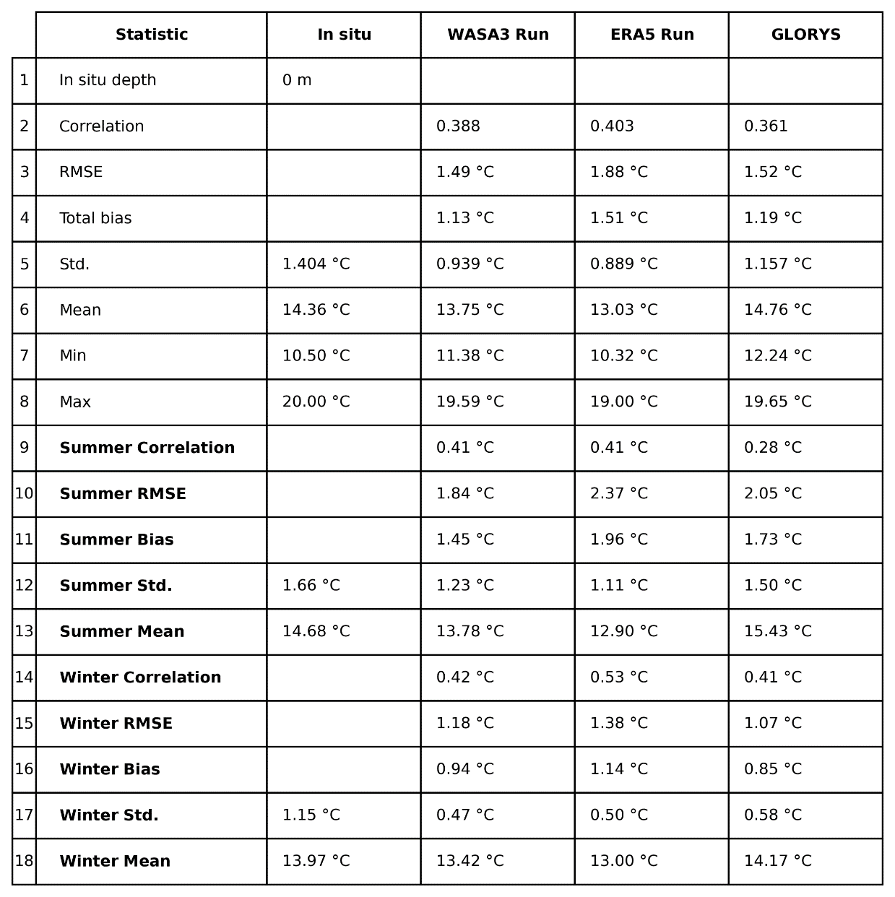

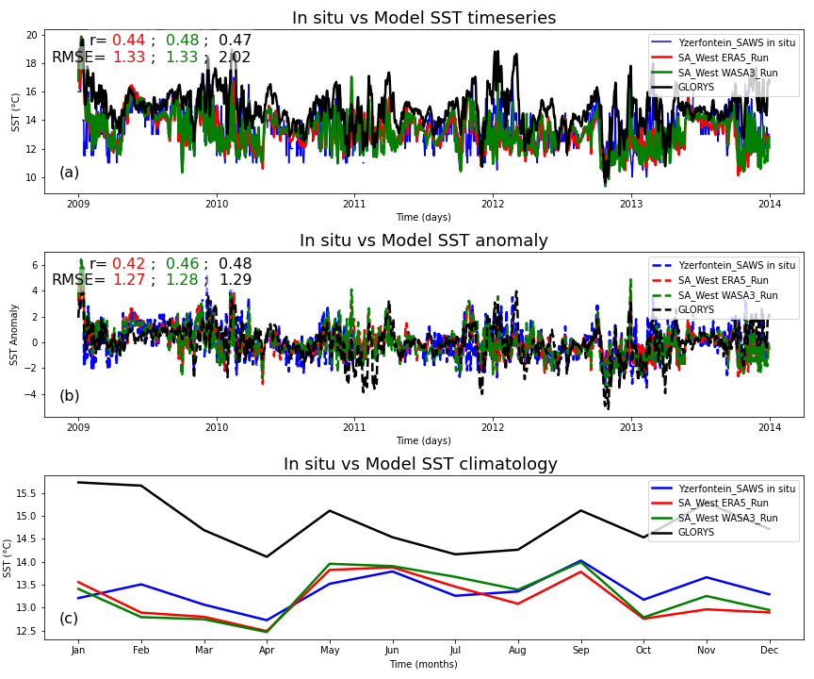

Figure 17: SST validation of the SA_West Model, both the ERA5 and WASA3 wind forced configurations at Yzerfontein_SAWS station located at [-33.361]: [18.157], depth = 0 m and a comparison with GLORYS global model. Subplot (a) shows SST time series, (b) shows anomaly series and (c) shows the climatology of the in situ SST vs the model outputs.

Table 15: Yzerfontein SAWS UTR total and seasonal statistics at surface where CROCO model depth is 10 m.

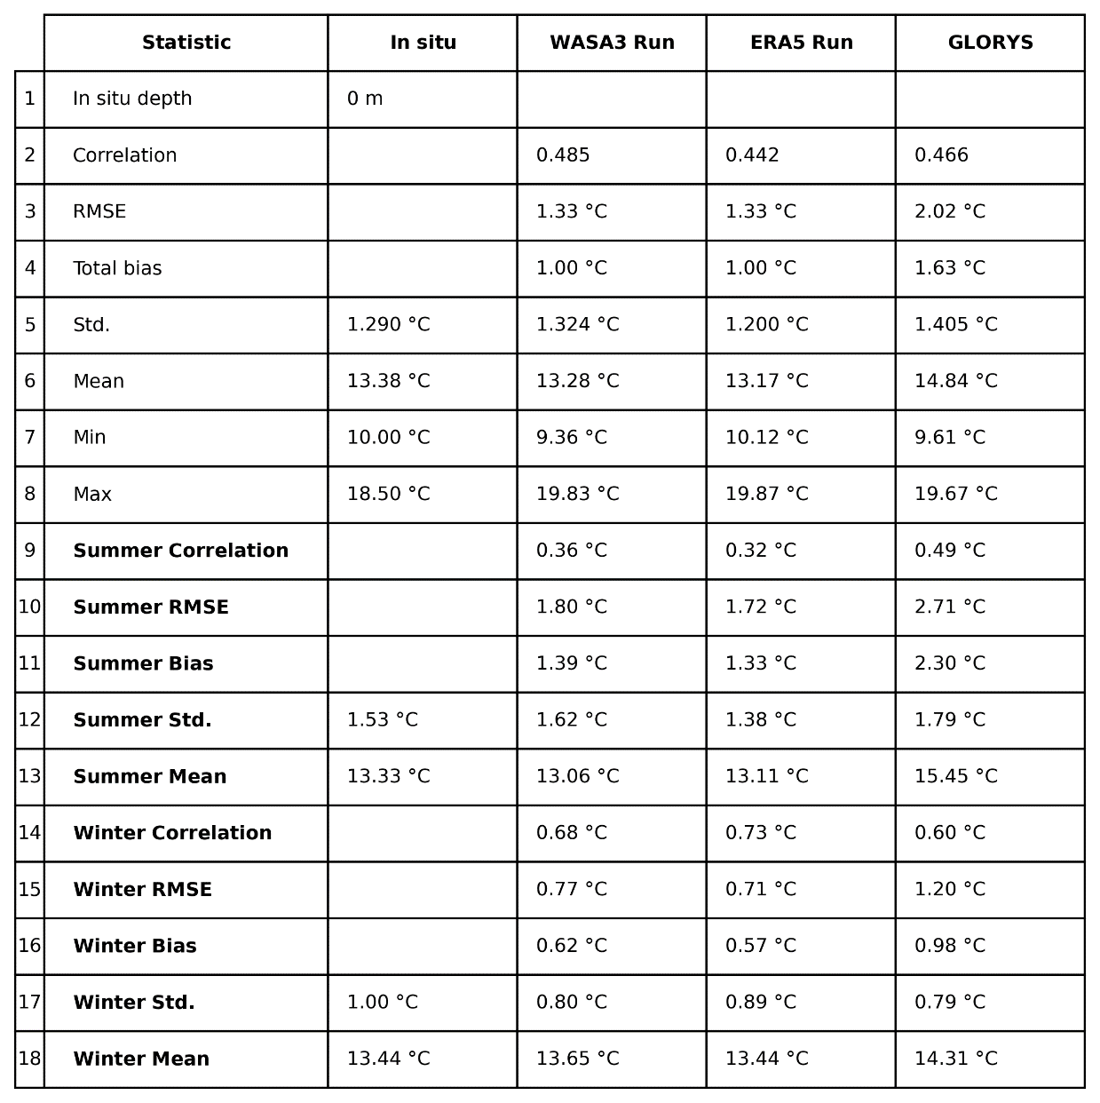

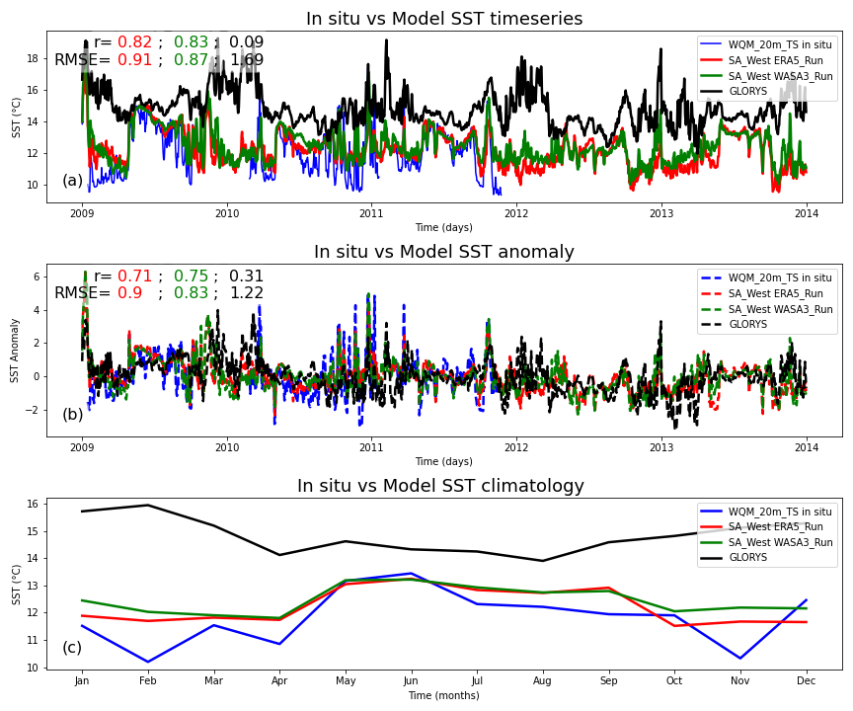

Figure 18: SST validation of the SA West Model, both the ERA5 and WASA3 wind forced configurations at WQM_20m_TS station located at [-32.292]: [18.318], depth = 20 m and a comparison with GLORYS global model. Subplot (a) shows SST time series, (b) shows anomaly series and (c) shows the climatology of the in situ SST vs the model outputs.

Table 14: WQM_20m_TS total and 20 m statistics at surface where CROCO model depth is 21 m.

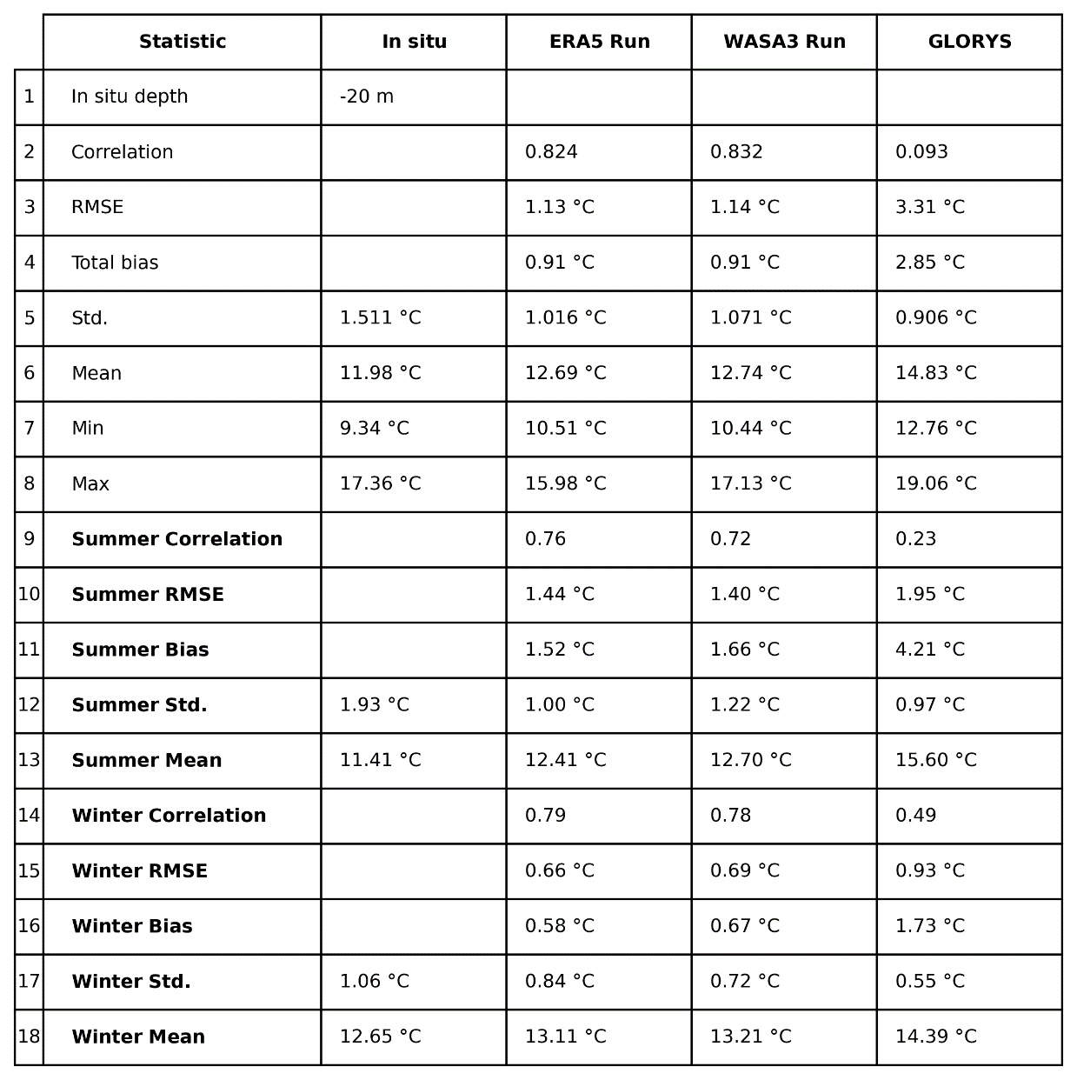

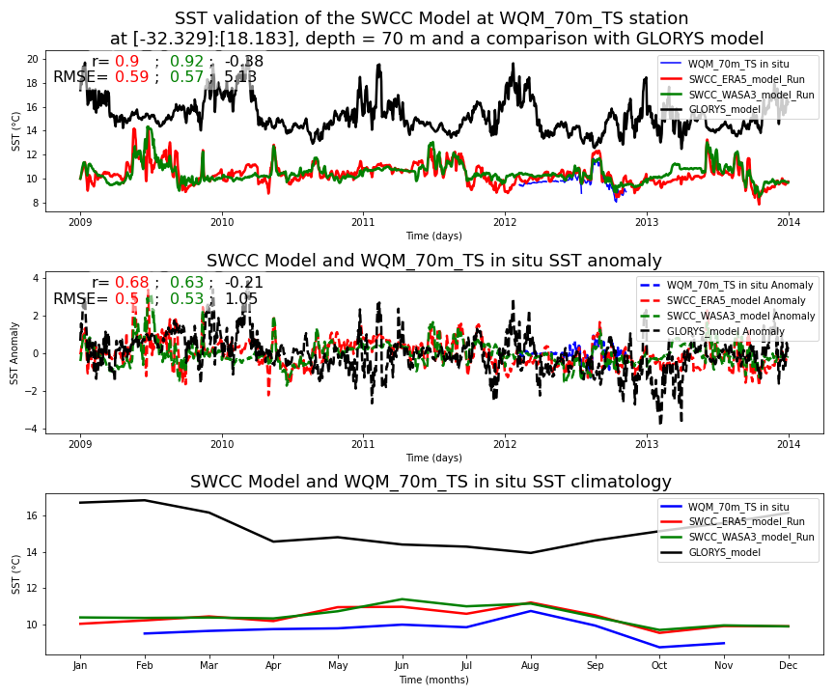

Figure 18: